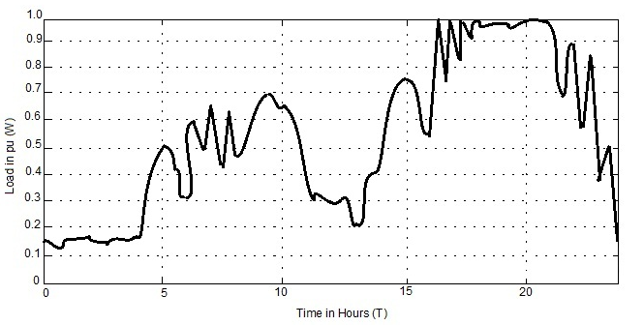 **Load curve of the day without Fuzzy Logic Controller**

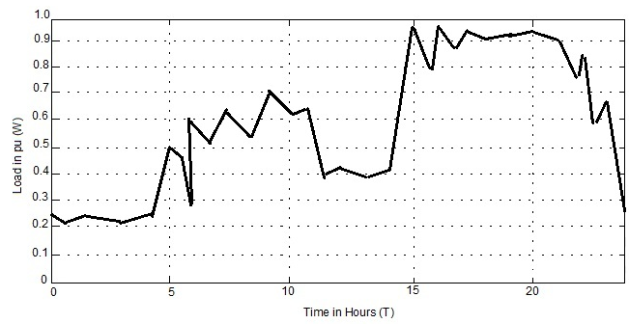 **Load curve of the day with Fuzzy Logic Controller**